📘 DocSpot: Seamless Appointment Booking for Health Full Stack MERN Project Documentation

PROJECT TITLE : DocSpot: Seamless Appointment Booking for Health
TEAM SIZE : 4
TEAM ID : LTVIP2026TMIDS49145
TEAM LEADER : Kanaparthi Swapna
TEAM MEMBER : Durga Prasad Karanti
TEAM MEMBER : Suvarna Gaddam
TEAM MEMBER : Grandhi Bhavithanjali
COLLEGE : Rise Krishna Sai Prakasam Group Of Institutions
🔖 1. Introduction
Overview:
DocSpot is a full-stack healthcare web application that streamlines the process of booking medical appointments. It provides a user-friendly interface for patients to book appointments online, doctors to manage their schedules, and administrators to oversee system operations. The app includes
secure role-based logins and integrated online payments for a complete appointment experience.

📌 2. Project Overview Purpose:
To provide a centralized, convenient, and secure platform for healthcare appointment management accessible by patients, doctors, and administrators.

Key Features:
- User (Patient) registration, login, and appointment booking
- Doctor login and appointment management dashboard
- Admin panel to manage users and appointments
- Razorpay integration for online payments
- Secure authentication using JWT

🏗️ 3. System Architecture Frontend (React.js)
- Built with React and React Router
- UI components from Material UI, Bootstrap, Ant Design
- Axios for HTTP requests

- Responsive design for mobile and desktop

Backend (Node.js + Express.js)
- RESTful API architecture
- Role-based access control
- Razorpay payment API integration
- JWT authentication and route protection

Database (MongoDB)
- Collections:
  - users (patients)
  - doctors
  - appointments
  - admins
  - payments
- Mongoose for schema definitions and data modeling

⚙️ 4. Setup Instructions Prerequisites:
- Node.js (v18+)
- MongoDB (Local or Atlas)
- npm
- Git

Installation & Setup:
bash
Copy code
# Clone repository
git clone https://github.com/your-username/docspot.git

# Frontend setup cd client
npm install

Frontend terminal:
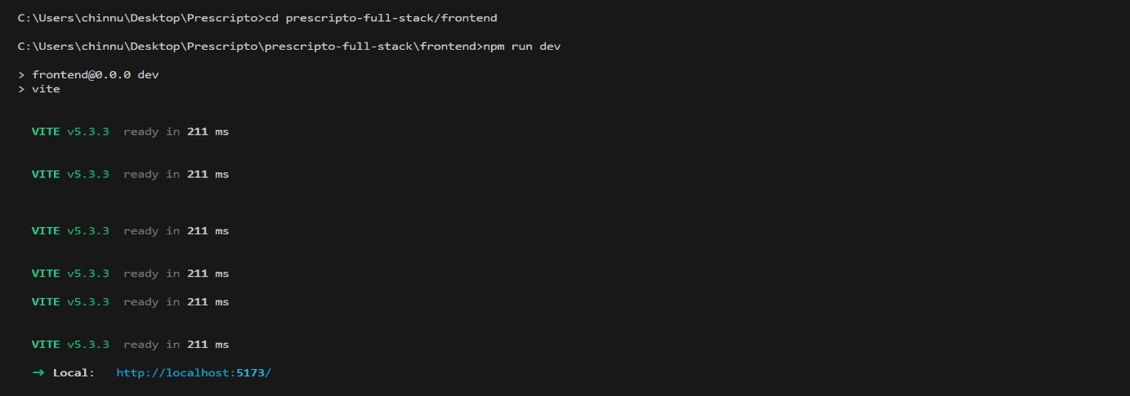

# Backend setup cd ../server npm install

Backend terminal:

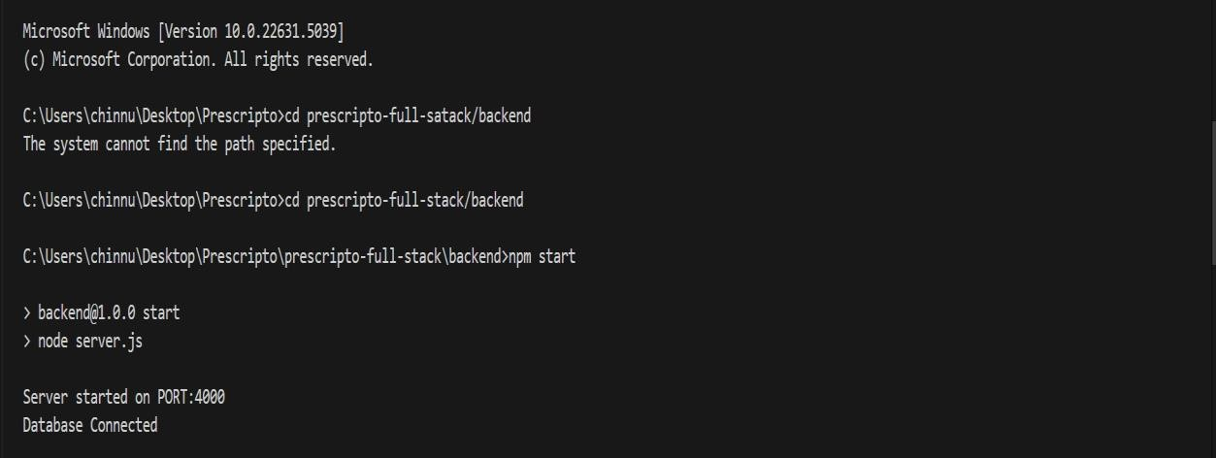

# .env file in /server/
MONGO_URI=your_mongo_uri JWT_SECRET=your_jwt_secret
RAZORPAY_KEY=your_razorpay_key

RAZORPAY_SECRET=your_razorpay_secret PORT=5000

5. Folder Structure

Client:
pgsql Copy code client/
├── public/
├── src/
│ ├── components/
│ ├── pages/
│ ├── context/
│ └── App.js, index.js

Server:
pgsql Copy code server/
├── controllers/
├── routes/
├── models/
├── config/
├── middlewares/
└── server.js

Backend Folder Structure:

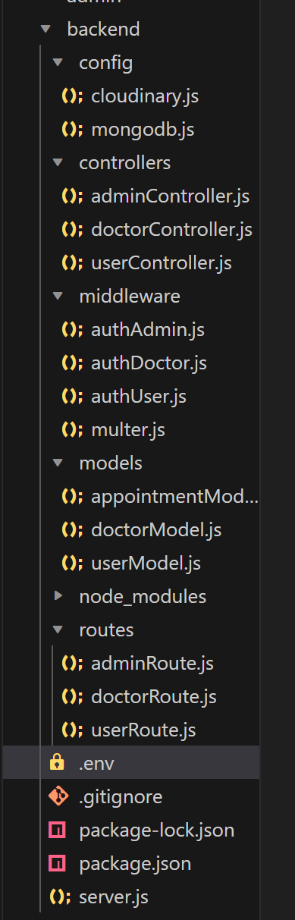

Frontend Folder Structure:

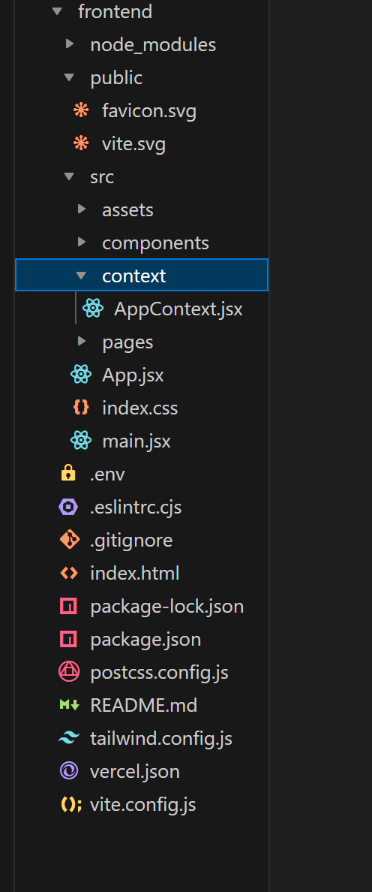

Admin Folder Setup:
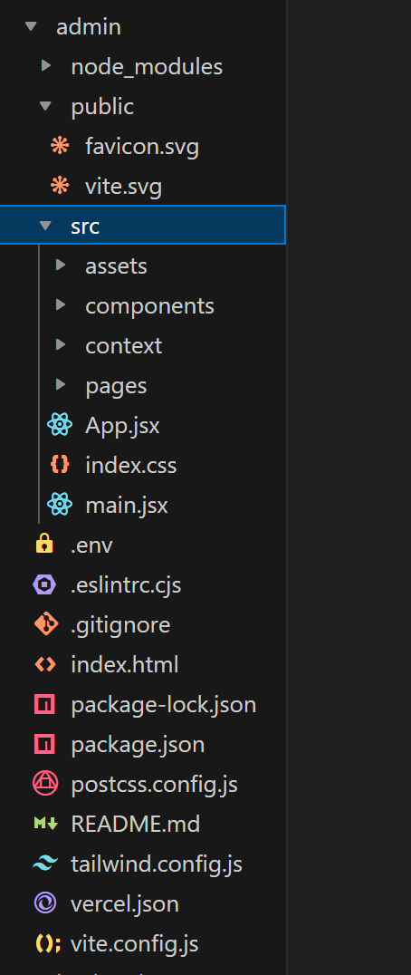

▶️ 6. Running the Application
bash
Copy code # Frontend cd client npm start

# Backend cd server npm start

📡 7. API Documentation

Method | Endpoint | Description
POST | /api/users/register | Register a new user
POST | /api/users/login | Login as user
POST | /api/doctors/login | Doctor login
POST | /api/admin/login | Admin login
POST | /api/appointments/book | Book an appointment
GET | /api/doctors/:id/appointments | Doctor views appointments
GET | /api/admin/appointments | Admin views all appointments
POST | /api/payments/order | Initiate Razorpay order
POST | /api/payments/verify | Verify payment

🔐 8. Authentication & Authorization
- JWT Tokens used for secure authentication
- Protected Routes: Based on roles (User, Doctor, Admin)

Token Flow:
  - On login, token is generated and stored in local storage
  - Every protected request includes this token in the headers

🎨 9. User Interface Screenshots
Please upload the following screenshots with the specified names:

Page | Screenshot Name
User Login Page | user-login.png
Doctor Login Page | doctor-login.png
Admin Login Page | admin-login.png
User Dashboard (after login) | user-dashboard.png
Appointment Booking Page | book-appointment.png
Payment Checkout Page | payment-page.png
Doctor Dashboard | doctor-dashboard.png
Admin Dashboard | admin-dashboard.png
Success Message after Booking | success-booking.png
Payment Success Page | payment-success.png

Home page(website):
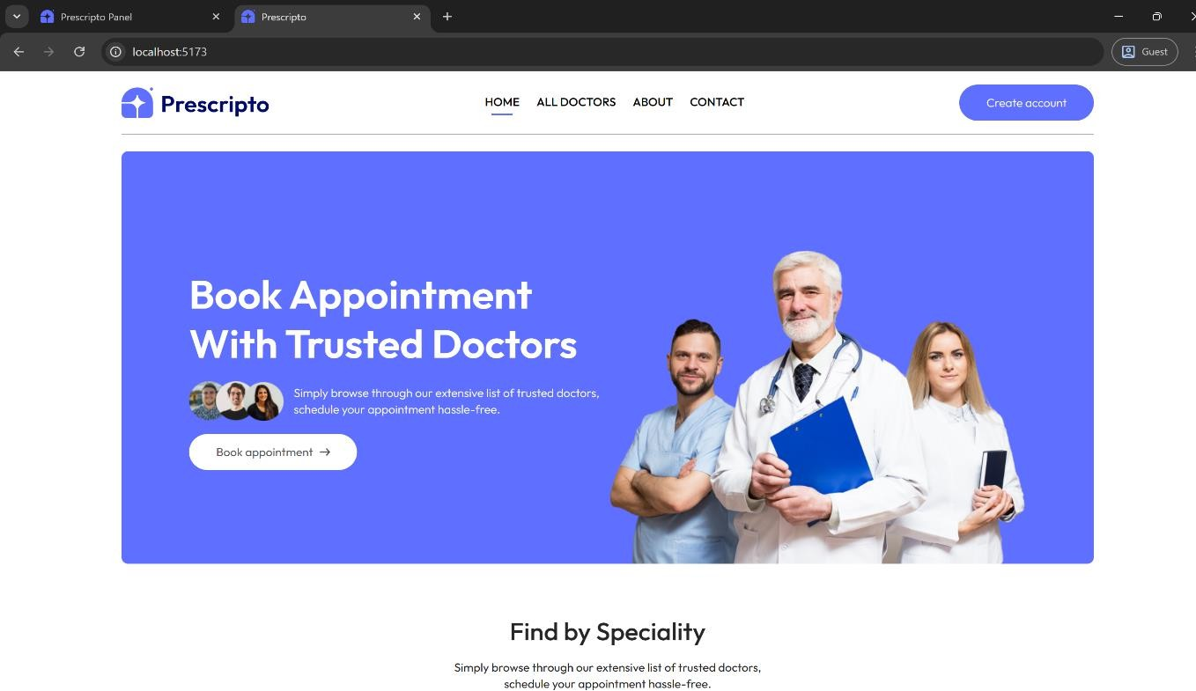

User Login:
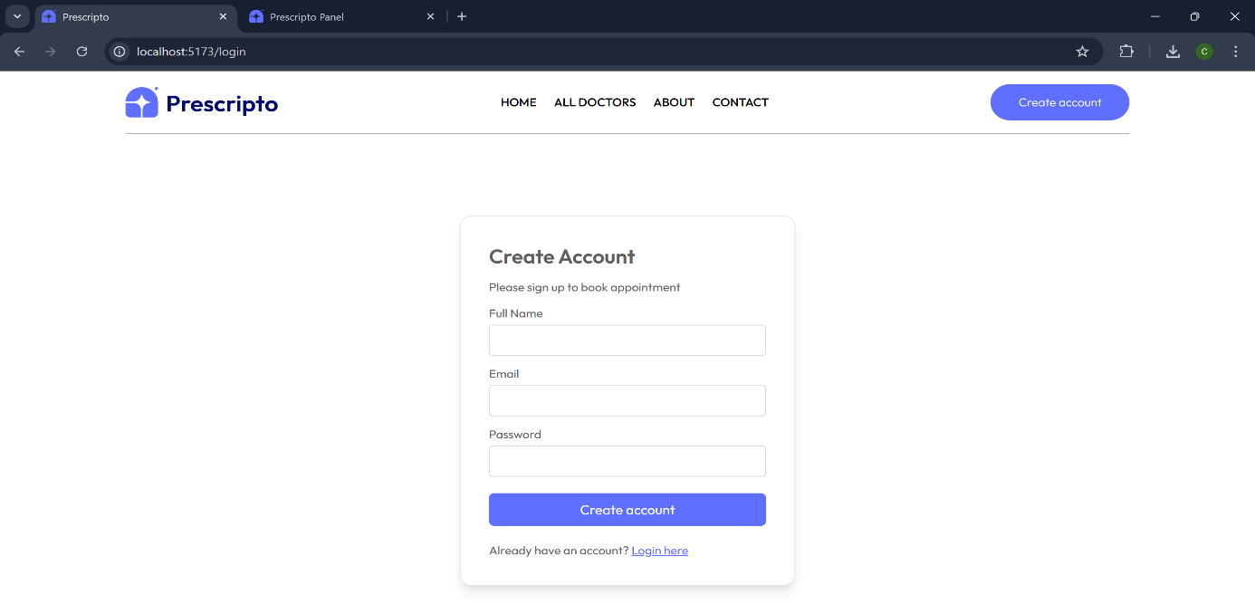

User Dashboard:
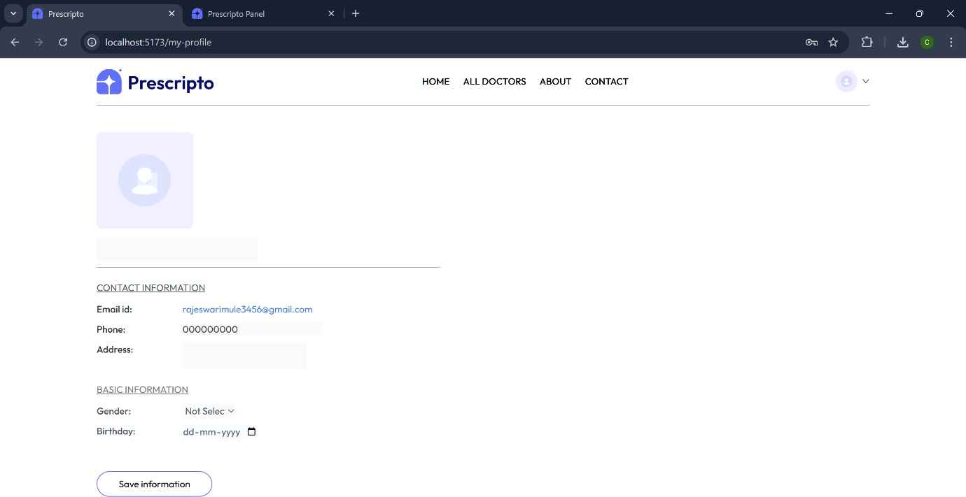


Admin Login Page:
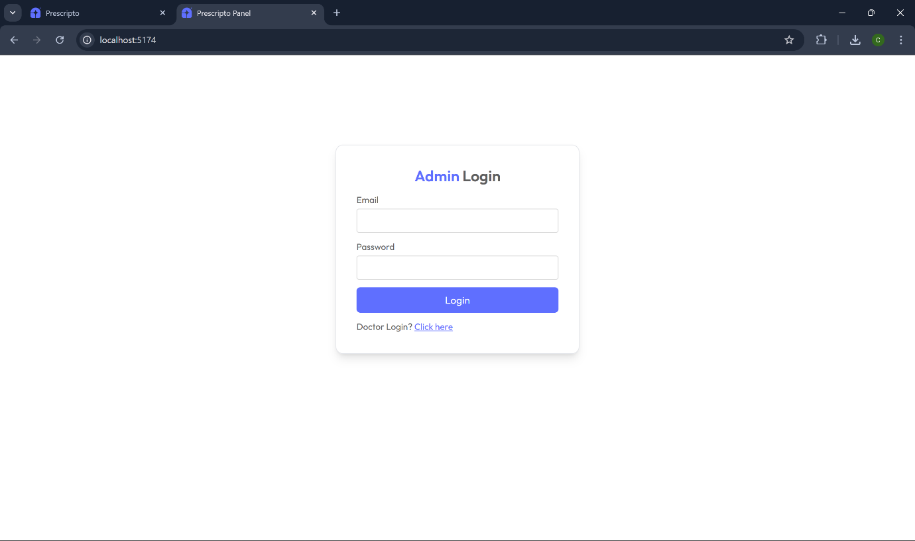

Admin Dashboard Page:

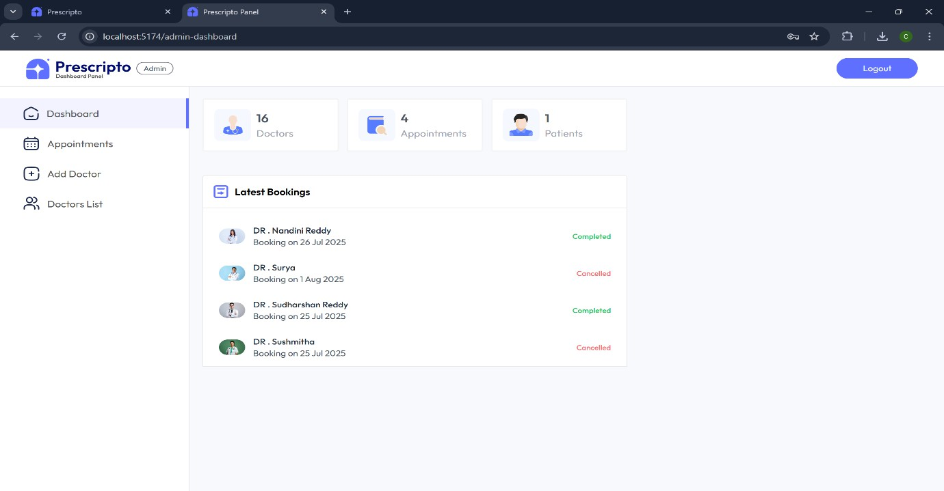

Doctor Login Page:
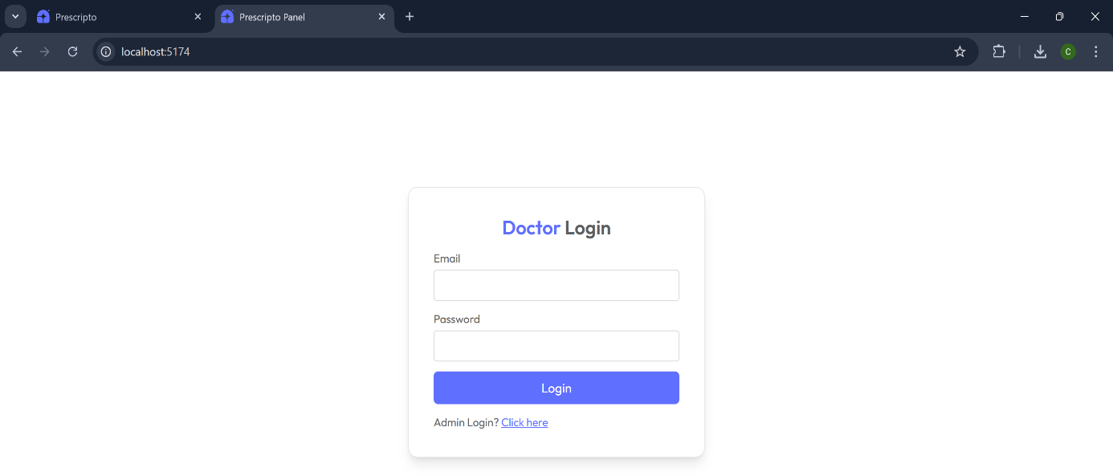

Doctor Dashboard:

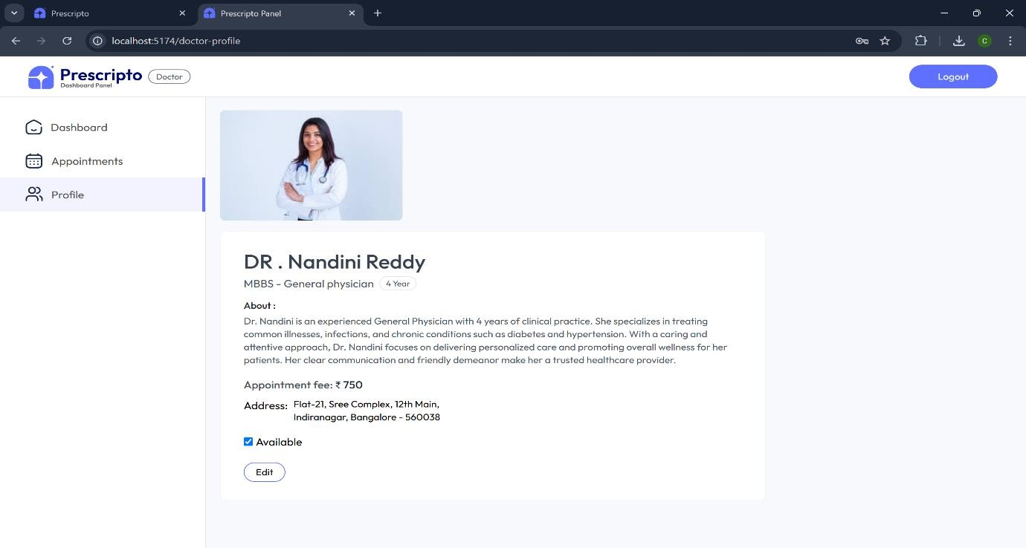
Appointment Booking:
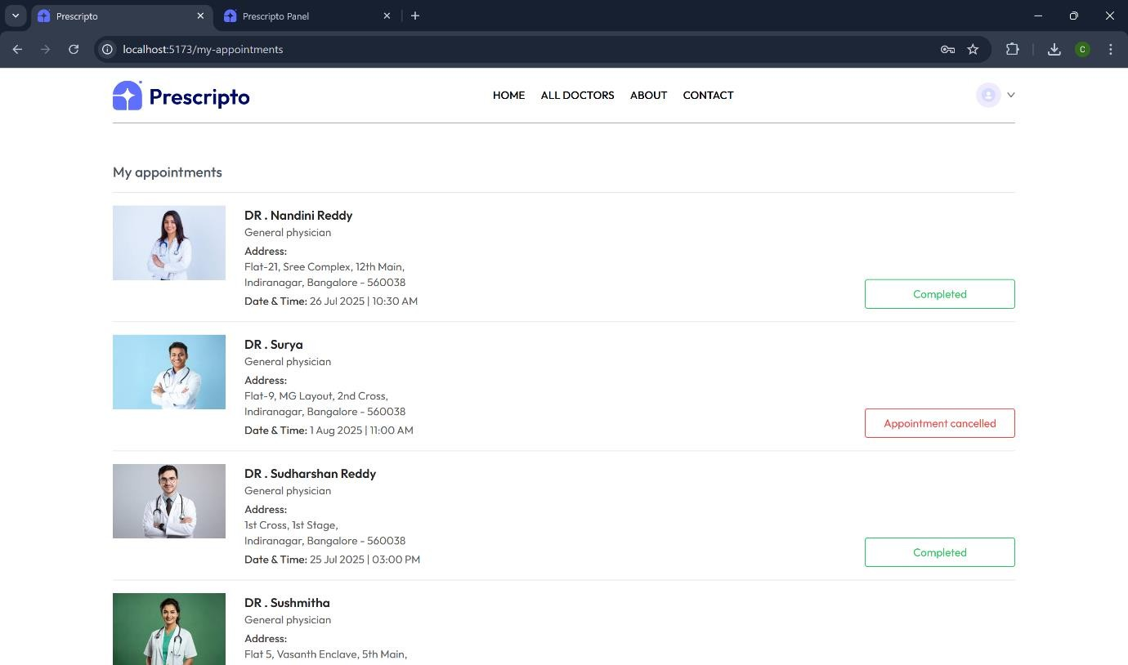

Appointment Booked Successfully:

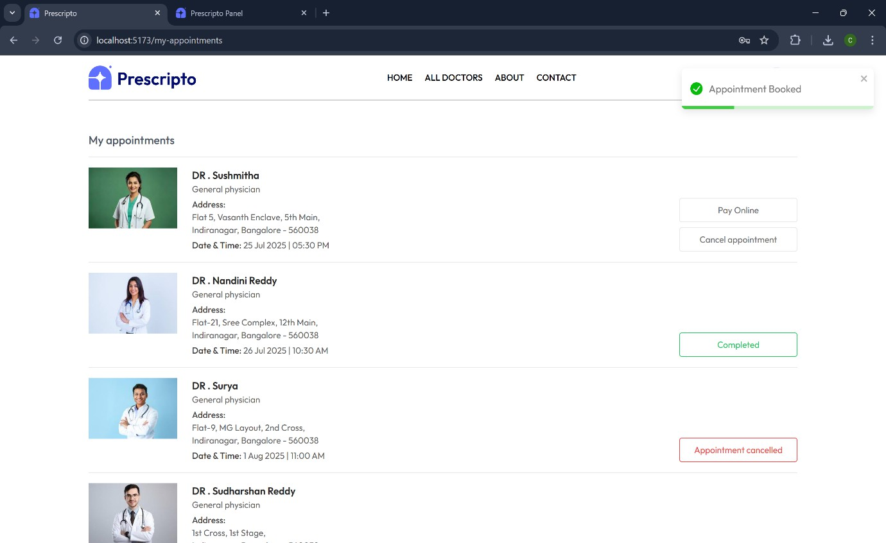

10. Testing Tools Used:
  - Postman – Backend API testing
  - Lighthouse – Frontend performance and accessibility
  - Browser DevTools – UI and console validation

Testing Coverage:
  - User login/logout and protected routes
  - Doctor and admin access control
  - Appointment conflict handling
  - Payment success/failure scenarios

📷 11. Demo or Showcase
  - Screenshots: As listed above
  - Optional Demo Video Link: [Insert YouTube/Google Drive demo link]

⚠️ 12. Known Issues
  - No pagination for appointment list
  - Doctor profile editing not implemented
  - No email/SMS notifications yet

🚀 13. Future Enhancements
  - Implement video consultations via WebRTC or Jitsi
  - Add appointment filtering (by date/speciality)
  - Notifications for appointment reminders
  - Email confirmations for patients
  - Real-time availability for doctors

📌 14. Conclusion
DocSpot successfully integrates frontend and backend technologies to deliver a secure and user- friendly platform for medical appointment management. With online payments and role-based control, it lays the groundwork for scalable future enhancements in digital healthcare.

